30.31: 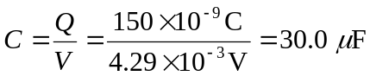
For an L-C circuit, 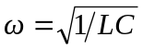and 